TESHUVAH:

Being Your Best Self!
During the days leading up to and including Rosh Hashanah, we spend a lot of time in shul asking Hashem for forgiveness for things we may have done wrong over the course of the year, and we ask for a successful year, a healthy year, and a peaceful year. Also, we are encouraged to reach out to people who maybe we have not spoken to in a while or people we may have had disagreements with and make amends. We can all think to ourselves and make a list of people who might appreciate a phone call, or might be excited to get a text, or wants to become friends again.
The months of Elul and Tishrei which contain Rosh Hashana and Yom Kippur, focus specifically on the middot and character traits of repentance, charity, and prayer. So let's explore how we can include this attribute of Teshuva (Repentance) this Rosh Hashana season, and why it is so important!
תְּשׁוּבָה- (Teshuva) which is translated as Repentance
This is the act of us righting a wrong, big or small, and it can take place whether it’s between you and a friend, or you and Hashem!
During the days leading up to Rosh Hashanah, it is a special time for us to ask for forgiveness and work on ourselves.
What are 3 things you can work on? (It can be something as small as trying to say good things about other people or letting your younger sibling pick what TV show to watch).
Fill in below:
__________________________________________________________
__________________________________________________________

___________________________________________________________

One of the most fundamental Mitzvot (Commandments) that we are taught is to “walk in G-ds ways”
This comes from Parshat Vahetchanan, in the 5th Chapter, 30th verse:
בְּכָל־הַדֶּ֗רֶךְ אֲשֶׁ֨ר צִוָּ֜ה ה’ אֱלֹקְיכֶ֛ם אֶתְכֶ֖ם תֵּלֵ֑כוּ”
“ You must walk in all the ways that the lord, your G-d has commanded you”
We can see from this verse that we are taught to mimic Hashem’s ways, this is a reason we are commanded to show compassion to others, be generous, and not to judge people too quickly.
The Torah gives us many examples of ways to follow Hashem.
So the question is, how does this relate to the character trait of teshuva (Repentance) and in turn becoming a better more inclusive person?
Throughout the Selichot leading up to Rosh Hashana and Yom Kippur, we repeat the below verse countless times:
שמות ל״ד:ו׳-ז׳
(ו) וַיַּעֲבֹר ה’ עַל פָּנָיו וַיִּקְרָא ה’ ה’ אֵל רַחוּם וְחַנּוּן אֶרֶךְ אַפַּיִם וְרַב חֶסֶד וֶאֱמֶת. (ז) נֹצֵר חֶסֶד לָאֲלָפִים נֹשֵׂא עָו‍ֹן וָפֶשַׁע וְחַטָּאָה...
Exodus 34:6-7
(6) And G-d passed by before him, and proclaimed: ‘The LORD, the LORD, G-d, merciful and gracious, long-suffering, and abundant in goodness and truth; (7) keeping mercy unto the thousandth generation, forgiving iniquity and transgression and sin;
When we read this verse, we see certain middot or character traits present in Hashem, we have to ask ourselves: Am I walking in G-d's ways and emulating those middot?
(Place a check mark where you see yourself)
How am I doing with giving others the benefit of the doubt?
⚪ Great ⚪ Not Well ⚪ Somewhere in the middle
Am I Easily Forgiving?
⚪ Yes ⚪ No ⚪ Sometimes

This is something that I get angry easily about and I can work to do better:
____________________________________________________________________

____________________________________________________________________

Am I Kind to others?
⚪ Yes
⚪ No
⚪ Sometimes

How can I help other people out? Fill in below: Example (Helping carry someone’s groceries, calling up a friend I haven't spoken to in a while, volunteering at a local food bank, etc)
______________________________________________________________________

_______________________________________________________________________

________________________________________________________________________

If you are like me, you are in the middle on most of these questions!
We all have our times where it is hard to forgive someone or it is hard to help someone out! The message of Rosh Hashana is one of growth and striving to be a better person and have better middot and character traits.
So we all have to take upon ourselves something to accomplish real teshuva and real character growth.

A Challenge for You:
Write down below two goals for this upcoming year: It could be something simple like getting better at a sport or musical instrument, or it could be a bigger goal like being a more sensitive person:

_____________________________________________________________________________

_____________________________________________________________________________

_____________________________________________________________________________

CANDY APPLES:

Apples are a huge part of Rosh Hashanah! Let's make them even yummier!

What you will need:
- 3 large apples of your choice
- 1 cup of chocolate chips
- 1 cup of peanut butter
- 1 cup of caramel chips
- 1 cup of white chocolate chips
- Large sticks
- Anything to decorate with (Sprinkles, Nuts, M n M’s etc.)

Let’s get started:
- Place sticks inside of apples
- Melt chocolate chips
- Melt peanut butter
- Melt the caramel chips
- Melt the white chocolate chips
- Dip the apples in each topping of your choice
- Decorate with whatever you want!
- Place in fridge to dry and harden

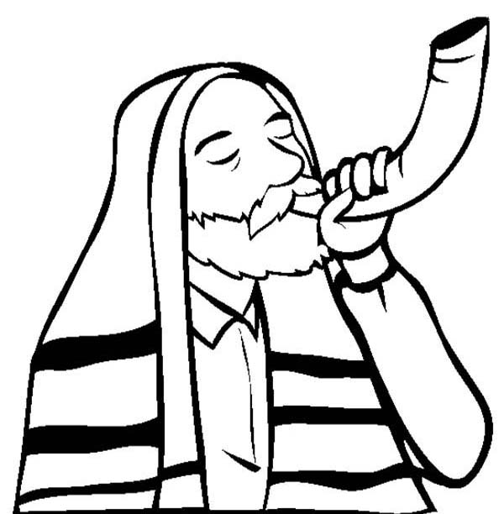

ROSH HASHANAH Q & A
Questions:
- Why do we blow the shofar during the month of Elul?
- Where in the written Torah text does it tell us explicitly that the first day of Tisrei is Rosh Hashanah?
- We eat apples dipped in honey to symbolize a sweet year. Why do we choose apples above other sweet fruits?
- What two blessings do we say before sounding the shofar?
- Which Book of Tanach does the beginning of the Tashlich prayer come from?
- What three barren women were "remembered" by Hashem on Rosh Hashanah?
- A person's yearly allowance is fixed on Rosh Hashanah, except for three types of expenses. What are they?
- We refer to the binding of Isaac in our prayers when we say: "Answer us as You answered Abraham our father on Mount Moriah…" What was Abraham's prayer on Mount Moriah?
- Why, even in Israel, are there two days of Rosh Hashanah, whereas other festivals in Israel are celebrated for only one day?
- What halacha applies to the shehechiyanu blessing on the second night of Rosh Hashanah which does not apply on the second night of any other holiday?

ROSH HASHANAH Q &A
Answers:
- Why do we blow the shofar during the month of Elul?
After the sin of the golden calf, Moshe went up to Mount Sinai to receive the second set of Tablets on Rosh Chodesh Elul. On that day, the Jewish People sounded the shofar to remind themselves to stray no more after idol worship. Also, the sound of the shofar strikes awe into our hearts and inspires us to return to the ways of Torah. (Mishna Berura and Aruch Hashulchan Orach Chaim 581)
- Where in the written Torah text does it tell us explicitly that the first day of Tisrei is Rosh Hashanah?
Nowhere. The Torah calls it "a day of shofar blowing." (This is one of many examples showing how our observance depends on the continuous oral tradition dating back to Mount Sinai). (Bamidbar 29:1)
- We eat apples dipped in honey to symbolize a sweet year. Why do we choose apples above other sweet fruits?
Isaac blessed Jacob with the words: "The fragrance of my son is like the fragrance of a field which Hashem has blessed…" (Bereishis 27:27). The Talmud identifies this "field" as an apple orchard. (Ta'anis 29b, Biyur Hagra)
- What two blessings do we say before sounding the shofar?
"Blessed are You… who has commanded us to hear the sound of the shofar," and the shehechiyanu blessing. (Orach Chaim 581:2)
- Which Book of Tanach does the beginning of the Tashlich prayer come from?
The Book of Micha (7:18-20).
- What three barren women were "remembered" by Hashem on Rosh Hashanah?
Sara, Rachel and Chana. On Rosh Hashanah it was decreed that these barren women would bear children. (Tractate Rosh Hashanah 10b)
- A person's yearly allowance is fixed on Rosh Hashanah, except for three types of expenses. What are they?
Expenses for Shabbos, Yom Tov, and the cost of one's children's Torah education. (Ba'er Hetaiv Orach Chaim 242:1)
- We refer to the binding of Isaac in our prayers when we say: "Answer us as You answered Abraham our father on Mount Moriah…" What was Abraham's prayer on Mount Moriah?
He prayed that Mount Moriah should remain a place of prayer for all future generations (Onkelos 22:14). Also, he prayed that his sacrifice of the ram should be considered as though he had actually sacrificed Isaac. (Rashi 22:13)
- Why, even in Israel, are there two days of Rosh Hashanah, whereas other festivals in Israel are celebrated for only one day?
Before our current exile, we did not have a fixed calendar as we do today. Rather, the Supreme Torah court in Jerusalem determined our calendar on a month to month basis. They did this on the first day of every month, based on witnesses testifying that they had seen the new moon. Therefore, the people outside Israel had insufficient time to find out the exact date in time for the festivals. The "two-day festival" arose to correct this situation. In Israel, however, the people lived close enough to Jerusalem to find out the exact date of all the festivals except Rosh Hashanah. Since Rosh Hashanah occurs on the first day of the month, even those living in Jerusalem sometimes needed to observe it for two days, if the witnesses failed to arrive.
- What halacha applies to the shehechiyanu blessing on the second night of Rosh Hashanah which does not apply on the second night of any other holiday?
On the second night of Rosh Hashanah it is customary to wear a new garment or to have a new fruit on the table when saying the shehechiyanu blessing. Thus, the shehechiyanu blessing applies not only to the holiday, but to the new garment or new fruit as well. (This is done in order to accommodate the minority of halachic authorities who rule that no shehechiyanu blessing be said on the second night of Rosh Hashanah.) (Taz 600:2)



TEFFILAH:
The Rosh Hashana prayer of וּנְתַנֶּה תֹּקֶף (Unetaneh Tokef) concludes with the phrase
“וּתְשׁוּבָה וּתְפִלָּה וּצְדָקָה מַעֲבִירִין אֶת רֹעַ הַגְּזֵרָה”
“Teshuva, Tefilah, and Tzedakah can remove the evil decree”

It is very reassuring and comforting to know that through these three acts we can change Hashem’s plan for us from bad to good.

You may be wondering, though, what is so special about these three acts Teshuva, Tefilah, and Tzedakah that they have the power to change Hashem’s mind about our future?
Let’s dig a little deeper into “Tefillah” and try to understand what it is and why it is so powerful.

What is Tefillah?
Tefillah is commonly translated as prayer and it is through Tefillah/prayer we have a direct line of communication to Hashem.

Imagine the following scenario:
You are the lucky winner of a worldwide contest for the chance to spend 1 hour with the world’s most powerful person. In just one week, you will have the undivided attention of a person who can make almost anything and everything you dream of into reality.

You spend days thinking about what you are going to talk about and ask for…… presents, clothes, games, toys, vacations… the options are endless!

As the big day comes closer, you ask a friend to help you decide what to ask for. He responds, “well…. Imagine you are one year in the future and you are looking back at everything you did, said, and had over the past year. Now, think about what were your happiest and proudest moments of the year? What mattered the most to you? Whatever those things may be, that is what you should be asking for. And remember, the things that mean the most to us are not things”

On Rosh Hashanah, we have our own special invitation to talk to the most powerful being in the world and ask for whatever we want.

We have a meeting with Hashem and prayer is our presentation.
Our Rosh Hashana prayers reveal our deepest and truest desires. They speak volumes about who we really are, what we really want, and why we believe we are worthy of living in Hashem’s world.

Stop and Think:
- What were the happiest and proudest of the past year?
- What mattered the most to you?
- What do you really want?
- How will you make the most of your time with Hashem?

Why are there special prayers for Rosh Hashana? Why can’t I just pray for what I really want?
There are two types of prayer.

1) Praying to Hashem whenever we want, for whatever we want, however we want. Hashem knows all and will always understand what you are asking for.

2) Saying the fixed prayers that are written in the siddur or Machzor. These prayers, like the ones we say on Rosh Hashana are less about asking Hashem for what we want and more about asking Hashem to teach us what to want.
Our Rosh Hashana prayers do not speak about new cars, a better job, or a special holiday trip because life, and our lives, is about more than these things. It is less about what we own and more about what we do and who we aspire to be.

When we ask Hashem for life, we hear an echo: Why? What are you planning to do with another year?

The fixed prayers help us answer that question. These prayers speak about forgiveness and about Hashem’s presence in our lives. They express a commitment to a life that is not just about us. By focusing on the important things in life and by thinking more deeply about the good we can do ... perhaps it will then actually become more fitting for us to accomplish our goals and desires.

Rosh Hashanah is not about personal requests. It’s about becoming the type of person more worthy of the goals we seek. We aim to grow more focused on what is ultimately better for us and for the world.

Stop and Think:
- What type of person do you want to be?
- What are your goals for the year?
- What can I do to make the world a better place?

So, am I praying for myself or for others??
Both. When praying for yourself you are praying for others and when praying for others you are praying for yourself.

The first line of the אָבִֽינוּ מַלְכֵּֽנוּ prayer can help explain this.
The words are:
אָבִֽינוּ מַלְכֵּֽנוּ חָטָֽאנוּ לְפָנֶֽיךָ
Our Father, our King, we have sinned before You.

Why does it say “we” have sinned? Shouldn’t it say “I” have sinned?

The Gemara (Shevuot 39a) says that all Jews are responsible one for another. The reason for this is that the Jewish people are like one body. So, one Jew who sins affects the entire Jewish people so too when one Jew does a good deed it has a good effect and benefits the entire Jewish people (Rambam, Teshuvah 3:4).

We’re All in the Same Boat
A passenger on a boat once noticed another passenger drilling under his seat. Very confused, he asked, “What are you doing?! You are letting water into the boat!”

The other passenger responded, “Mind your own business. I’m drilling under my seat. I paid my fare, and this is my seat.”

The man said to him, “I understand that, but don’t you realize that if water comes in under your seat, it will sink everyone onboard!”

If Hashem knows everything that I am thinking why do I have to actually say the prayers out loud?
Rabbi Yitzchok Kirzner and Lisa Aiken explain in “The Art of Jewish Prayer” that it is not enough simply to “think” a prayer, or to have a certain feeling in one’s heart toward Hashem. Jewish prayer requires that people actually say the words that they think or feel.
Why do we have to verbalize prayer? Why can’t we just feel something in our hearts and communicate it to God through our thoughts?

By communicating our thoughts and feelings through words, we are declaring our willingness to act upon them and turn them into reality. We need Hashem to hear our prayers and truly believe that we mean what we say. When we speak, we show that we have confidence in our words and wish that our words are heard.

If a tree falls in a forest and there is no one there, does it make a sound??

Usually, a person doesn’t speak out loud unless there is someone there to listen.

Thankfully, for us, we know Hashem is there and ready to listen.

One for all and all for One
As we have learned, our prayers have tremendous power to impact not only our own lives but the lives of others as well.

We, the Jewish people, can achieve far more as a united whole than we can as individuals. Each city, community, family, and person can contribute something of unique and infinite value to the world.

Therefore, it is very fitting that on Rosh Hashana, millions of Jews from around the world all pray to Hashem. Whether at home, in a backyard, or in shul, as you thank, praise, and ask Hashem for a good decree, keep in mind that you have the great opportunity, responsibility, and power to change your life and world.

HONEY CAKE:

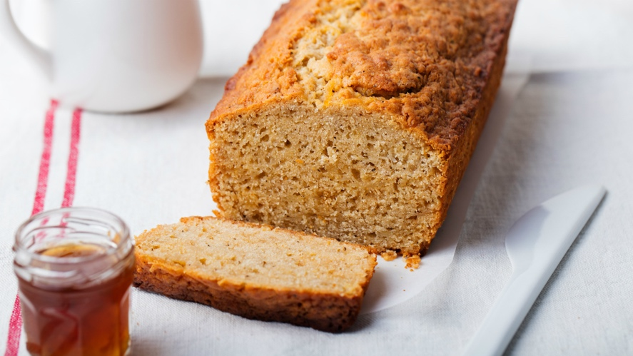
We use honey to dip our apples in for a sweet new year! What better way to enjoy some more honey then in a cake!
What you will need:
- 10 eggs separated
- ½ cup white sugar
- ½ cup brown sugar
- ½ cup oil
- ½ cup of honey
- 1 teaspoon of baking soda dissolved in orange juice
- 1 teaspoon of cinnamon
- 1 and ½ cup of flour

Let’s get started:
- Preheat oven to 325 degrees Fahrenheit.
- In the large bowl of an electric mixer, cream the yolks and brown sugar. Add the remaining ingredients (excluding egg whites and white sugar) and beat until fully combined.
- In another bowl, beat the whites, adding sugar in a steady stream as the whites begin to stiffen. Beat until stiff peaks form.
- Fold the whites into the batter. Using a rubber spatula, mix until just combined.
- Pour the batter into the pan.
- Bake for one hour and 10 minutes.

TZEDAKAH:

Giving to others is a fundamental aspect of Judaism. The Torah recounts many times when the Jewish people are instructed to help one another. In one such case, Jewish farmers are instructed to leave portions of their crop in their fields so that those who are in need can come and take (Leviticus 19:9-11).

Today, giving Tzedaka often refers to donating money. If we are able, it is our responsibility to ensure that those around us are taken care of and have access to basic necessities. Additionally, when we donate money to organizations that are important to us, it helps them continue to do the important work they do.

But the Torah source reminds us that charity extends far beyond just that. If giving charity stems from supporting our brothers and sisters, all of us can take part in the Tzedaka process. There are many things we can do to help care for others.

Living to be Giving
The holidays can be a busy time in our households! Stepping up to help or doing something nice for someone else can go such a long way! On the lines below, fill in 1 thing you can commit to doing for someone else. This can be something helpful like cleaning up around your house or something someone will appreciate like writing a card or giving someone a phone call before the holiday!

For A Parent/ Guardian: ___________________________________________________

For A Sibling/ Family Member: ______________________________________________

For A Friend/ Neighbour: __________________________________________________

Charity: For You or For Me
The Rambam, a famous Jewish commentator, created 8 levels of giving referred to as a Tzedaka ladder. From the Rambam’s work we learn that giving is not one-sided; it is just as impactful for the person who gets as it is for the person who gives. Why do you think this is so?
We also learn that giving charity is not simply about what we give, rather it’s about how we give it. Are we giving willingly or unwillingly? Does giving make us feel happy or apprehensive?

As you make your way up the ladder (with #8 being the highest form of giving), try and think of 1 practical example for each level of giving and fill it in on the lines below! Remember, giving doesn’t only mean giving money, it could also mean giving your time, giving a listening ear, giving a helpful hand, giving advice or support and so much more!

8. Helping another person be able to support them self

Example: ___________________________________________________________________

7. You don’t know who you have given to, and the receiver doesn’t know who they have received from

Example: ____________________________________________________________________

6. You know who you are giving to but no one else knows you gave

Example: _____________________________________________________________________

5. You give without knowing who will receive but the receiver knows who gave

Example: _____________________________________________________________________

4. You give before being asked
Example: _____________________________________________________________________

3. You give after being asked

Example: _____________________________________________________________________

2. You give but less than you could

Example: _____________________________________________________________________

1.You give but you don’t really want to

Example: _____________________________________________________________________

As you may notice, the form of giving described in the Torah had the farmers involved in one of the highest levels of giving. The farmers did not know who would receive the portions they left over and the receivers did not know from whose fields they were picking.

An important aspect of giving is that it is done with integrity and respect. Hashem gives every person different skill sets and strengths, different access to resources and abilities. It is our job to ensure that we are using the tools Hashem has given us to take care of ourselves and those around us far and wide.

Activity: This Rosh Hashana as we attempt to be the best person we can be, we mimic Hashem’s kindness and generosity through our donations to others. On these pages, you indicated how you can donate resources (such as your time or support) to help those around you. Additionally, inside your package you will find a white Tzedaka box! Decorate your Tzedaka box and designate who you would like to donate the money to once your box is full!

POMEGRANATE SORBET
On Rosh Hashanah we eat many different things that represent something special in Jewish life. Pomegranates are known for having 613 seeds, just like our 613 Mitzvos! Here is a yummy, cold treat to cool you off!
What you will need:
- 3.5 cups of pomegranate juice
- 1 cup of sugar
- 1 large container
- Parchment paper
Let’s get started:
- Dissolve the sugar in 3 cups of the juice and pour into a container lined with parchment paper.
- Put container in the freezer.
- When the mixture is frozen solid, take it out, break it into pieces and process in a blender or food processor with the remaining half cup of pomegranate juice until smooth.
- Return it to the container and freeze until firm. Let defrost slightly before serving.

- Optional: Garnish with fresh pomegranate seeds.

